sqoop import --connect jdbc:mysql://localhost/school --username root -P --columns empId,empName,empDate --table company2 --target-dir /myhive --hive-import --create-hive-table --hive-table default.Company2Hive -m 1

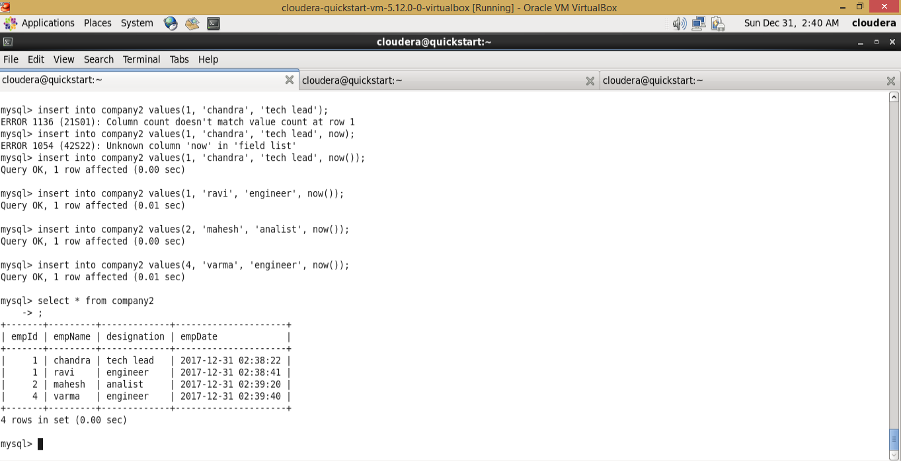

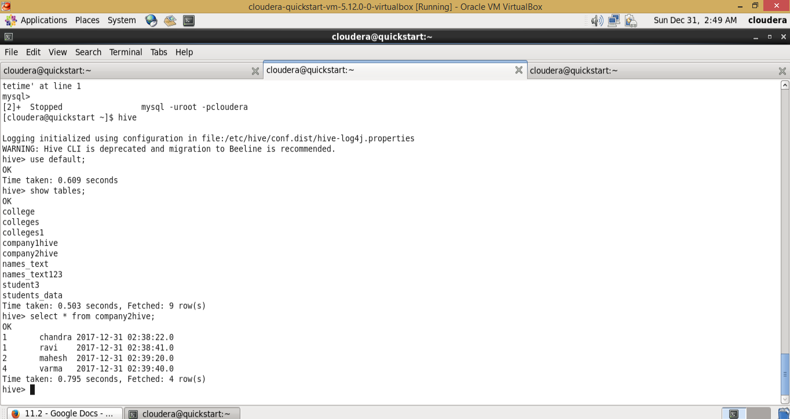

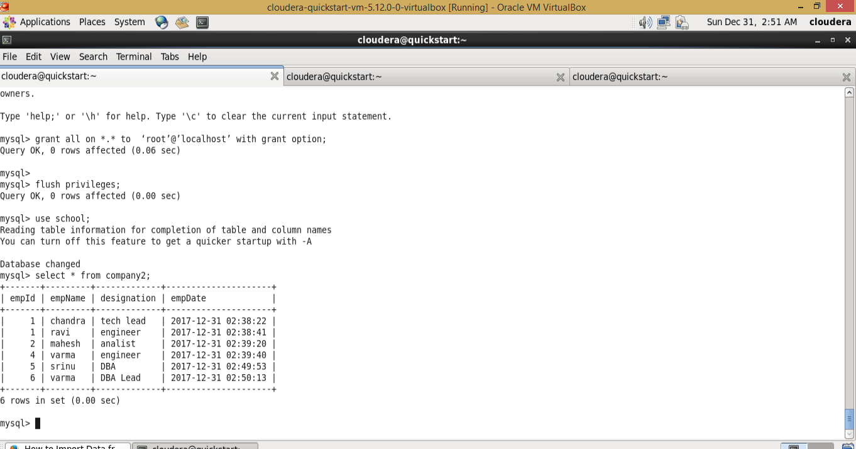

sqoop import --connect jdbc:mysql://localhost/school  --username root -P -m 1  --table company2  --append --hive-table default.Company2Hive --where "empId > 4" --check-column "empDate"  --last-value "2017-12-31 02:39:40" --incremental lastmodified  --target-dir /myhive

